
R-100

FM Programmable Digital Receiver
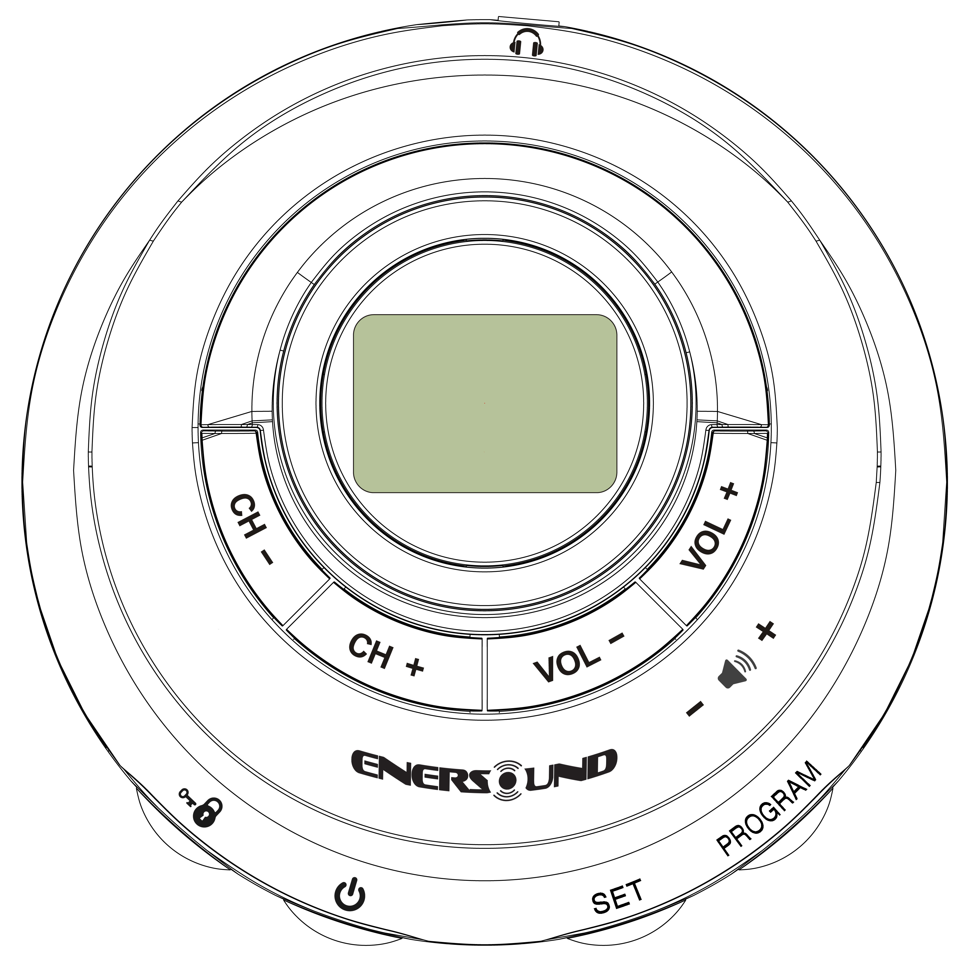

User Manual
V.1
Para descargar este manual en español, ingrese a: www.enersound.com/manuals
Para baixar este manual em português, acesse: www.enersound.com/manuals

INDEX

About This Manual...........................3
Safety Warnings................................4
Control Panel....................................7
Inserting Batteries.............................9
Selecting Carrying Option...............10
Care..................................................13
Using the Receiver...........................14
Turning the Receiver On and Off…14
Changing the Channel.....................15
Setting the Volume...........................15

Frequency Chart ..............................16
Locking/Unlocking the Receiver......16
Warranty......................................17-19
Technical Data..................................20
Disposal............................................20

NOTE: To turn the receiver on and off, gently press and hold the POWER button for approx. 2 seconds.

About this Manual
Read this user manual carefully before using your receiver. Use the product only as described to avoid accidental injury or damage. Also, read safety warnings carefully.
Keep this manual for future reference. If you give this product to someone else, remember to include this manual.

Symbols in this Manual

This symbol warns of hazards that may cause injury.
The word HAZARD indicates a life-threatening risk or the possibility that a significant personal injury may occur.


The word CAUTION represents the risk of slight injury or damage.
This is how supplementary information is shown.
Safety Warnings
Intended Use
This receiver is designed for private use.

HAZARD to Children
- Batteries can be highly dangerous if swallowed. Therefore, keep batteries and the receiver out of the reach of children. If a battery has been swallowed, seek medical assistance immediately.
- Keep the packaging out of children’s reach as it may cause suffocation!

HAZARD! Neck Strap
Be careful when using the neck strap. Under unfavorable circumstances you could strangle yourself with the neck strap.
Never allow children to play with the neck strap. They could strangle themselves.
WARNING! Damage to your Health
- Using headphones at a loud volume or over a prolonged period of time can lead to permanent hearing damage.
- Batteries should not be recharged or reactivated by other means, taken apart, thrown into fire or short-circuited. There is a risk of explosion. Rechargeable batteries should only be charged outside the receiver and following instructions from the battery manufacturer using an approved charger.

CAUTION! Damages
- Protect the receiver against moisture, water, dust, extreme temperatures or direct sunlight.
- Never let the receiver fall, and do not expose it to a strong impact.
- Do not use the receiver or its accessories if there are any visible signs of damage.
- Remove batteries from the receiver if they are dead or if you do not intend to use the receiver for a prolonged period of time. This will avoid damage that may be caused by leakage.
- Never take the receiver or its accessories apart. Have repairs carried out by the manufacturer only.
- Do not use caustic cleaning products, benzene, solvents, etc. for cleaning. These substances may damage the surface of the case.
- Always replace all batteries at once and do not mix different battery types, brands or batteries with different capacities.

HAZARD! Pacemaker Safety
- Before using this receiver with a pacemaker or another medical device, consult your physician or the manufacturer of your pacemaker or another medical device.
- If you have a pacemaker or another medical device, make sure that you are using this receiver in accordance with safety guidelines established by your physician or the pacemaker manufacturer.

Front View
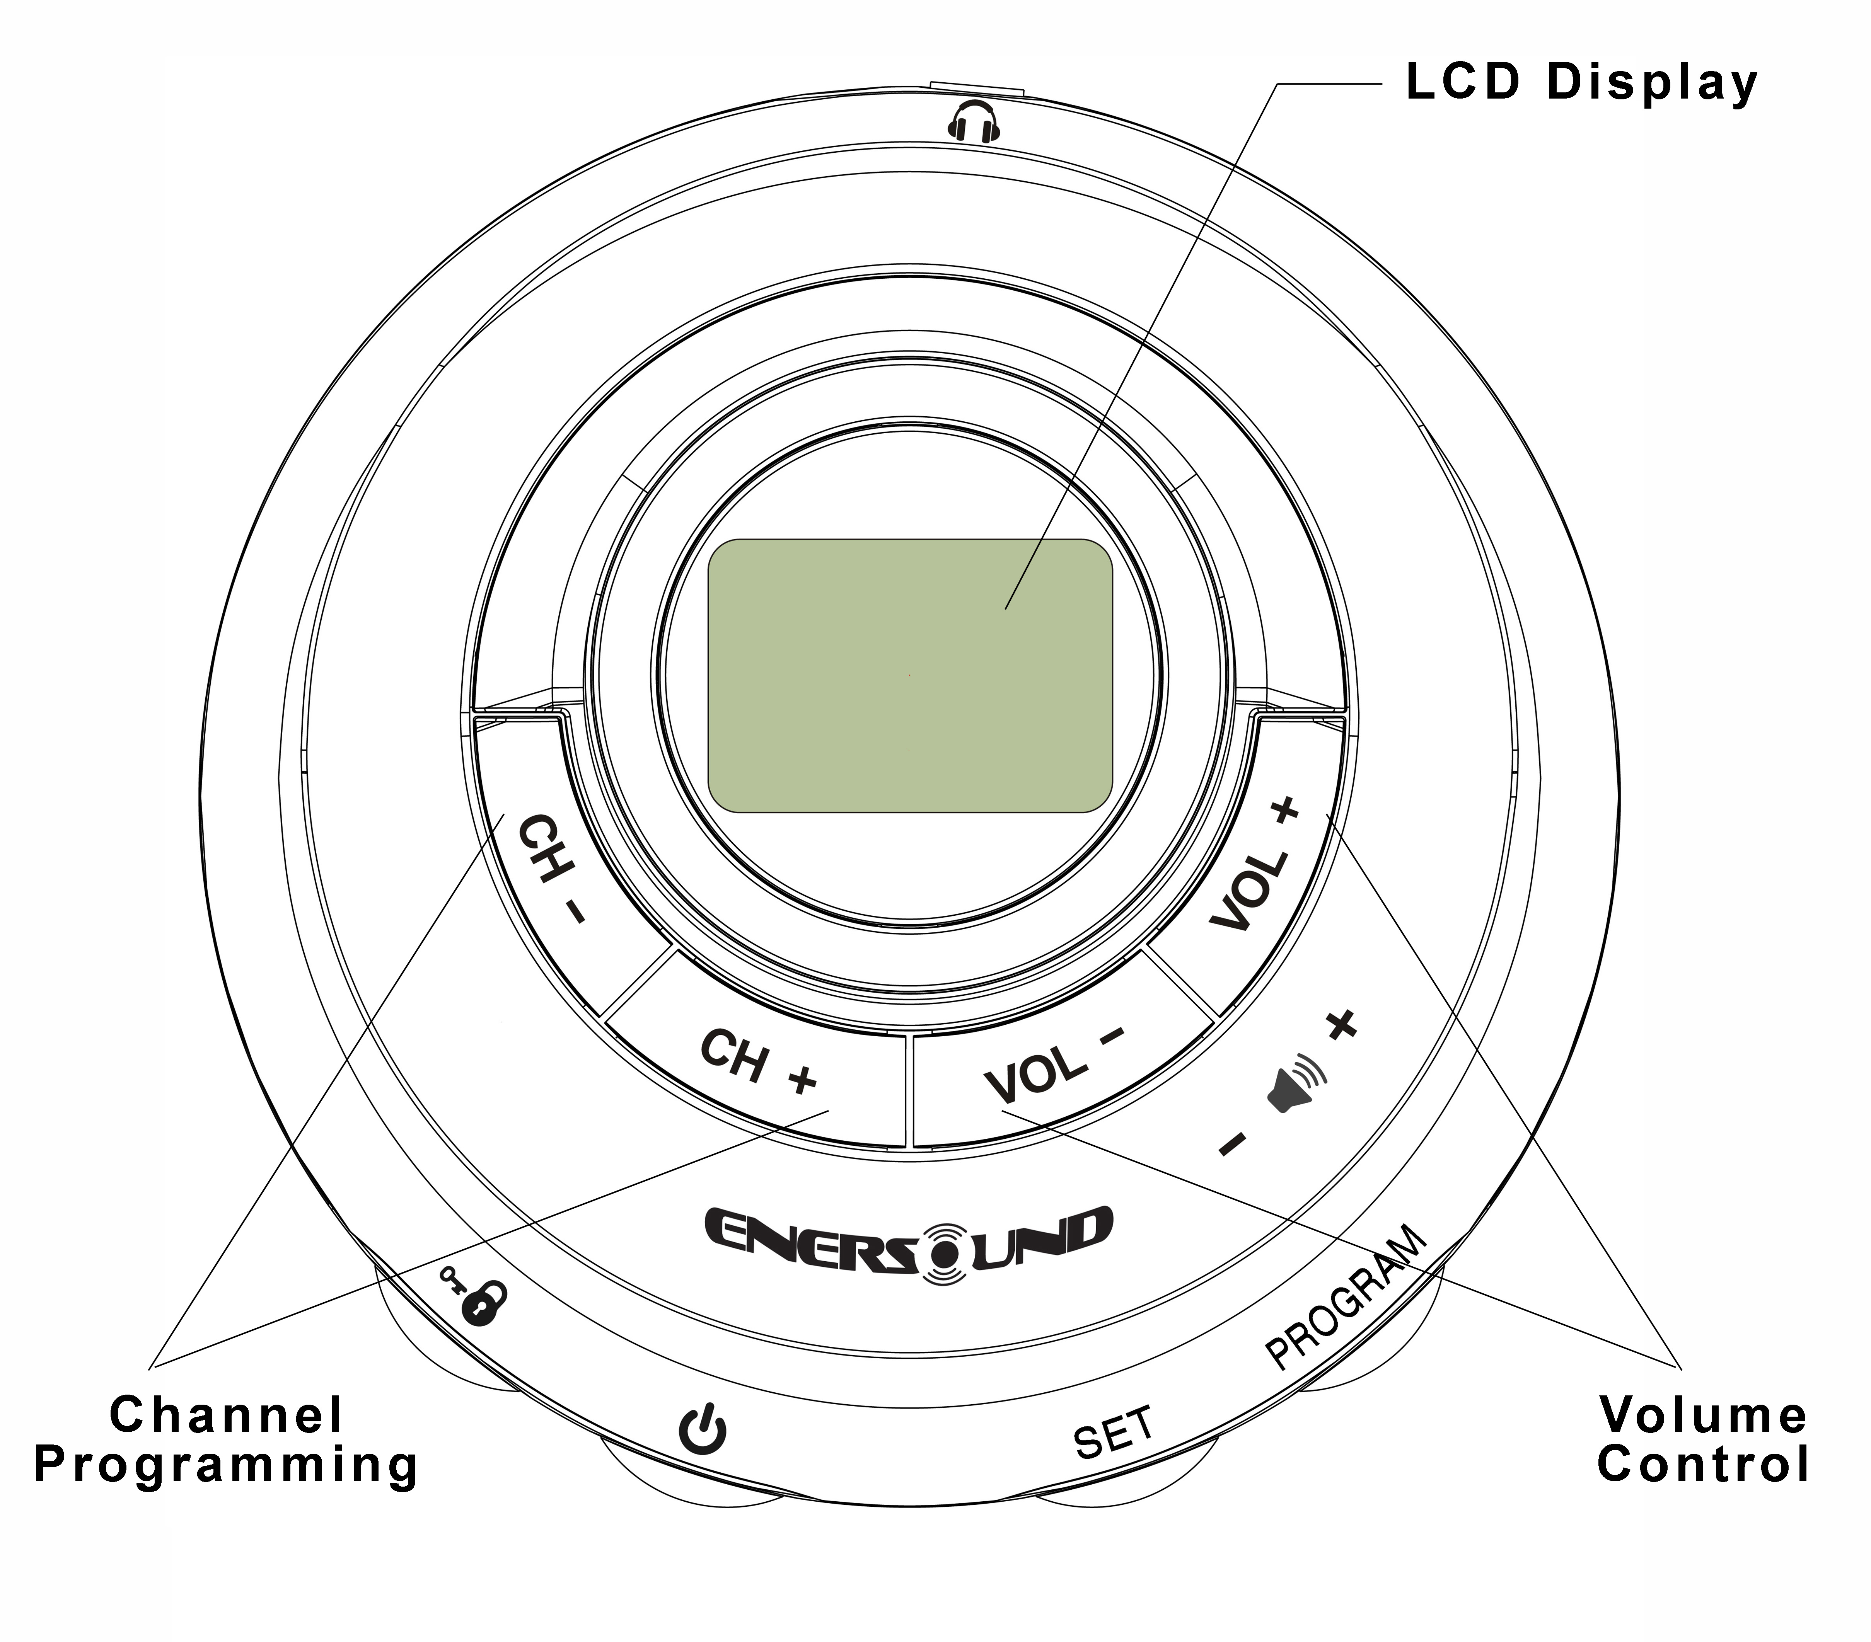
Side View
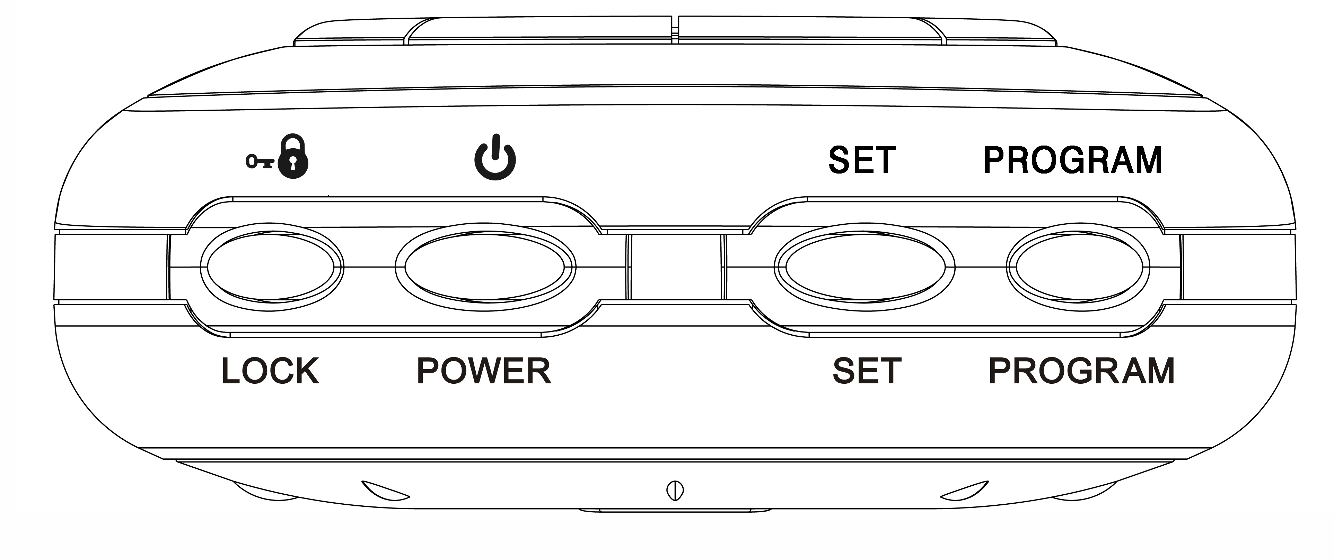

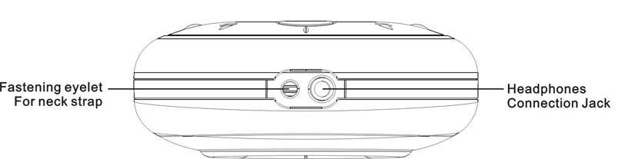

Inserting Batteries
- Turn the battery cover on the back side of the receiver counterclockwise as far as it will go (follow the OPEN arrow).
- Remove the battery cover. If necessary, tap the receiver against the palm of your hand to loosen the cover.
- Insert batteries as indicated on the base of the battery compartment.
Make sure that the polarity is correct (+/-).
- Replace the battery cover and turn it clockwise until it locks.

Information about Replacing Batteries
  - Replace batteries when the battery symbol in the display is flashing. Any program saved will remain stored.
  - If the belt clip is attached to the receiver, you will have to unscrew it before opening the battery cover.
  - For the best performance, use AAA alkaline batteries. You may also use AAA NiMH rechargeable batteries. Do not use any other type of batteries besides Alkaline or NiMH.

Selecting Carrying Option
Carrying Options at a Glance

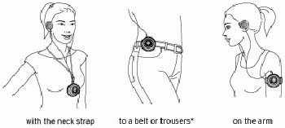

Option 1- Using the Neck Strap
HAZARD: When worn around the neck, the neck strap presents a risk of strangulation. Keep the receiver, including the neck strap, out of reach of children. Never allow children to play with the neck strap. Particular care must be taken when the receiver is attached to the neck strap.

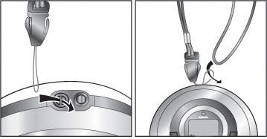
The strap is already threaded, but it can easily be removed. However, if you want to thread it again at a later time, proceed as follows:
1. Thread the thin loop of the neck strap through the eyelet on the upper side of the receiver. If necessary, use a bent paperclip for help.

2. Pull the other end of the neck strap completely through the loop.

Option 2- Attached to your Belt
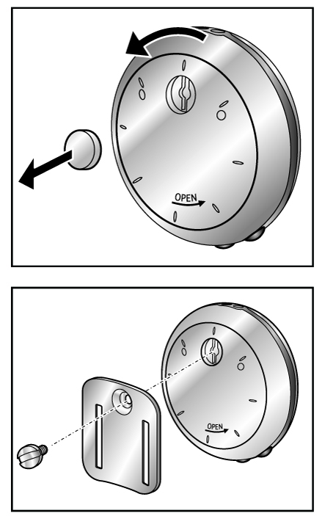

- Remove the battery cover on the back side by turning it counterclockwise.
- Pull or press the small cap out.
- Replace the battery cover.
- Using the screw, attach the belt clip to the receiver.

Keep the cap in a safe place; you might want to remove the belt clip in the future and close the opening.
Do not insert your belt through the clip slots. They are designed for the arm band.

Option 3- On the Arm
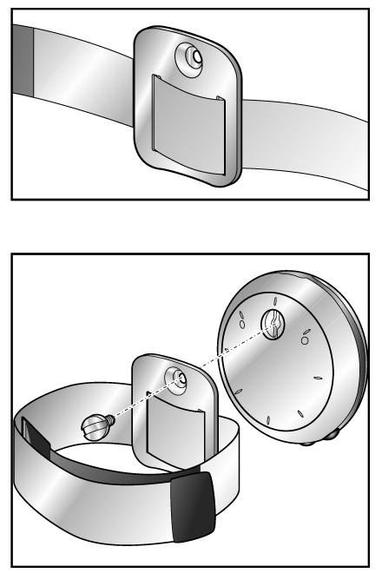
1. Insert the arm band through the slots of the belt clip.
2. Proceed as described above in “Option 2”.
3. Screw the belt clip to the receiver with the arm band pulled through.

Use the Velcro to fit the arm band to your arm width.

Taking Care of the receiver:
CAUTION! Damage to the Unit
Do not use caustic cleaners, alcohol, thinners, etc. to clean the case.
Whenever necessary, use a soft, dry cloth to clean the case.

Using the Receiver

WARNING : The use of headphones/earphones at a loud volume or over a prolonged period of time can lead to permanent hearing damage.
Set the volume at a low level before putting the headphones on.
(On the optional model R-100BL, the display will light up for a few seconds when a button is pressed while the receiver is in operation. When the battery charge is under 1/3 approximately, the receiver will operate in a “save” mode in which the back light is turned off. The standard receiver R-100 does not include a backlight.)
The headphone cord also serves as an antenna. Therefore, it should be fully extended.
Note: In the United States, the FCC rules limit use of this equipment to auditory assistance and simultaneous interpretation.

Turning the Receiver On and Off
Gently press and hold the POWER button for approx. 2 seconds.
Setting the Volume
To increase the volume: Press the VOLUME + button.
To decrease the volume: Press the VOLUME - button.

Changing Factory Set Channel
The receiver is factory pre-set to Channel 1 (72.1MHz). If you wish to modify the channel, please follow the steps listed below:

1. Press and hold the PROGRAM button for approx. 6 seconds to access the program mode, and the current channel will start blinking.
- Select the desired channel by pressing the CHANNEL+ or CHANNEL- button.
- Press the SET button to save your selection and exit the program mode. (Proceed within 10 seconds while setting, otherwise the unit will switch back to normal mode and you will have to repeat this procedure).
- Enersound Frequency Chart:
CH 1: 72.1 MHz | CH 6: 75.3 MHz | CH 11: 72.2 MHz | CH 16: 72.4 MHz
CH 2: 72.5 MHz | CH 7: 72.3 MHz | CH 12: 72.6 MHz | CH 17: 75.6 MHz
CH 3: 72.9 MHz | CH 8: 72.7 MHz | CH 13: 75.4 MHz | CH 18: 72.0 MHz
CH 4: 75.7 MHz | CH 9: 75.5 MHz | CH 14: 75.8 MHz | CH 19: 76.0 MHz
CH 5: 74.7 MHz | CH 10: 75.9 MHz | CH 15: 72.8 MHz | CH 20: 73.0 MHz
Note: For multi-channel operation in the same location it is recommended to leave a separation of at least 0.4 MHz between channels and place transmitter’s antennas at least 14 ft apart from each other.

Locking/Unlocking the Receiver
The receiver can be locked to prevent entering into program mode accidentally. The lock function will not affect “Volume” or “Power” buttons.
- To lock/unlock the receiver, press and hold the LOCK button for approx. 3 seconds until the key symbol appears/disappears on/from the bottom right corner of the display.
Limited 3-Year Warranty

Enersound warrants its R-100 receivers to be free from defects in workmanship and material under normal use and conditions for 3 years from date of purchase from an authorized dealer. All other products and accessories, including but not limited to headphones, earphones, belt clips, neck straps, cases, cables, etc. are warranted for one year from the date of purchase. This warranty is only available to the original end purchaser of the product and cannot be transferred. Limited 3-Year Warranty is only valid if warranty has been registered within 90 days of purchase, otherwise, R-120 receivers will be warranted for 1 year from date of purchase. To register your warranty, visit www.enersound.com/warranty-registration/, You can also register by e-mail at support@enersound.com or by mail at 5869 SW 21st ST, West Park, FL 33023, USA. Please include your name, contact information, products purchased and retailer name. If the product is determined to be defective, Enersound will repair or replace it, at its discretion, at no charge. Customer must pay for shipping, handling, insurance and any duties and taxes if applicable. This warranty is void if damage occurred because of misuse or if the product has been repaired or modified by anyone other than a factory-authorized service technician. Warranty does not cover normal wear and tear on the product or any other physical damage unless the damage was the result of a manufacturing defect. Damage due to battery leakage, water, sweat, corrosion, humidity, extreme temperature, chemicals or any other external factor is not covered under this warranty.
Reimbursement for your costs of removing and transporting the product for warranty service evaluation or installation of any replacement product are not covered by this warranty.
Enersound has no control over the conditions under which this product is used. Therefore, disclaims all warranties not set forth above, both express and implied, with respect to the R-100 receiver and accessories, including but not limited to any implied warranty of merchantability or fitness for a particular purpose. Enersound R-100’s manufacturer, distributors and/or dealers shall not be liable to any person or entity for any medical expenses or any direct, incidental or consequential damages caused by any use, defect, failure or malfunction of the product, whether a claim for such damages is based upon warranty, contract, tort or otherwise. The sole remedy for any defect, failure or malfunction of the product is replacement of the product. No person has any authority to bind Enersound to any representation or warranty with respect to the R-100 receiver. This warranty gives you specific legal rights, and you may also have other rights, which vary from state to state. Some states do not allow limitations on how long an implied warranty lasts, the exclusion or limitation of incidental or consequential damages, so the above limitation may not apply to you. This warranty does not cover products sold AS IS or WITH ALL FAULTS. For products sold outside the US, please consult with your local dealer about specific terms and conditions that may be applicable in your county. Proof of purchase in the form of a bill of sale, invoice number or receipted invoice, which is evidence that the unit is within the warranty period must be presented to obtain warranty service. If you experience difficulty with your product, send an email to support@enersound.com with your name, address, phone number and a complete description of the problem. We will respond to you as soon as possible and if it is necessary to return the product for service, your Customer Service Representative will give you a Return Authorization Number (RAN) and shipping instructions.

For more information, visit www.enersound.com.
You may also call 1-305-731-2416 or our toll-free number 1-800-644-5090 within the US.
Our address is 5869 SW 21st Street, West Park, FL 33023, USA.

This limited warranty, prices and the specifications of products are subject to change without notice.

2020 All rights reserved. www.enersound.com Technical Data

Model: R-100
Batteries: (2) Alkaline AAA (1.5V x 2)
Or (2) NiMH AAA Rechargeable
Battery life:
Up to 55 hours of use w/Alkaline Bat.
Up to 40 hours w/NiMH Rechargeable
Frequency range: FM 72.0 to 76.0 MHz.
FM deviation: +/- 75 KHz
De-emphasis: 75 uS.
Sensitivity: 1.12 uV at 12 db SINAD.

Signal to noise ratio: 55 db at 100 uV.
Audio frequency resp.: 80 Hz -12 Khz
Audio power: 33 mW +33 mW at 32 Ω
Audio connector: 3.5mm stereo jack.
Current consumption: 22 mA nominal
Dimensions: 3’’ Diameter / 76 mm.
High: 1.22” / 31 mm.
Weight : 2.3 ounces (65g).
Weight with batteries: 3.1 ounces (88g).

Disposal
Dispose the packaging in the proper manner. Containers for the proper disposal of batteries are provided at battery retailers as well as at local authority collection points.

Should you wish to dispose the product, do so in accordance with the latest local regulations. Details are available from your local authority.

