

*Passion for innovation*

**Model: TP-600**

Version: 4

SKU:TP-600-4

**Portable 4-Channel FM Transmitter**

(72-76 Mhz)

**USER MANUAL**

**TP-600-4 Table of Contents**

About this Manual…………………………………………. 3

Package Contents ………………………………………..… 3

System Overview …………………………………………… 3

Quick Reference:

Controls, Displays and Connectors……………….…. 5

Set-up Instructions ………………………………………… 8

General Set-Up Instructions ………………………… 8

Enersound Frequency Chart………………………… 12

Menu Setting Instructions …………………………… 14

Safety Information ……………..………………….…… 26

Trouble Shooting ………………..…………………….…… 29

FCC & IC Statements ……………………………….….…… 32

Limited Warranty Statement …………………...….… 35

TP-600-4 Optional Accessories ……………….…….… 38

Technical Specifications ……………………….………… 39

**About this Manual**

Read this user manual carefully before setting up and operating your TP-600-4 portable FM transmitter. Use the product only as described to avoid accidental injury, damage or hearing impairment. Also, read safety warnings carefully. Keep this manual for future reference. If you give this product to someone else, remember to include this manual.

**Package Contents**

(1) TP-600-4 Portable FM Transmitter (72-76 MHz)

(1) User Manual

**System Overview**

Thank you for choosing the Enersound TP-600-4 FM transmitter. This professional 4-channel portable transmitter, designed for assistive listening and language interpretation, wirelessly broadcasts a speaker’s voice, music or audio signal up to 150 ft. The audience can use an optional Enersound FM receiver or any other compatible FM receiver operating within the 72-76 MHz frequency band to pick up the broadcast. It features 2 audio inputs, including a 3.5 mm locking jack for headset microphones, and a 2.5 mm jack as an auxiliary audio input.

The TP-600-4 features a dedicated MUTE button conveniently located on the upper side of the unit that enables the user to silence the microphone and enable it back.

Its LCD display allows the user to easily program the various useful functions, such as the microphone and auxiliary gains, compression ratio, display mode (frequencies or channel numbers), and battery type.

The TP-600-4 is powered by either Alkaline or NiMH rechargeable batteries. It features an on-screen battery level indicator. When used with NiMH rechargeable batteries, the optional CHR-600 drop-in fast charger sold separately, allows to recharge the batteries without removing them from the transmitter. Battery life with alkaline batteries is up to 25 hours and up to 22 hours per charge with NiMH rechargeable batteries.

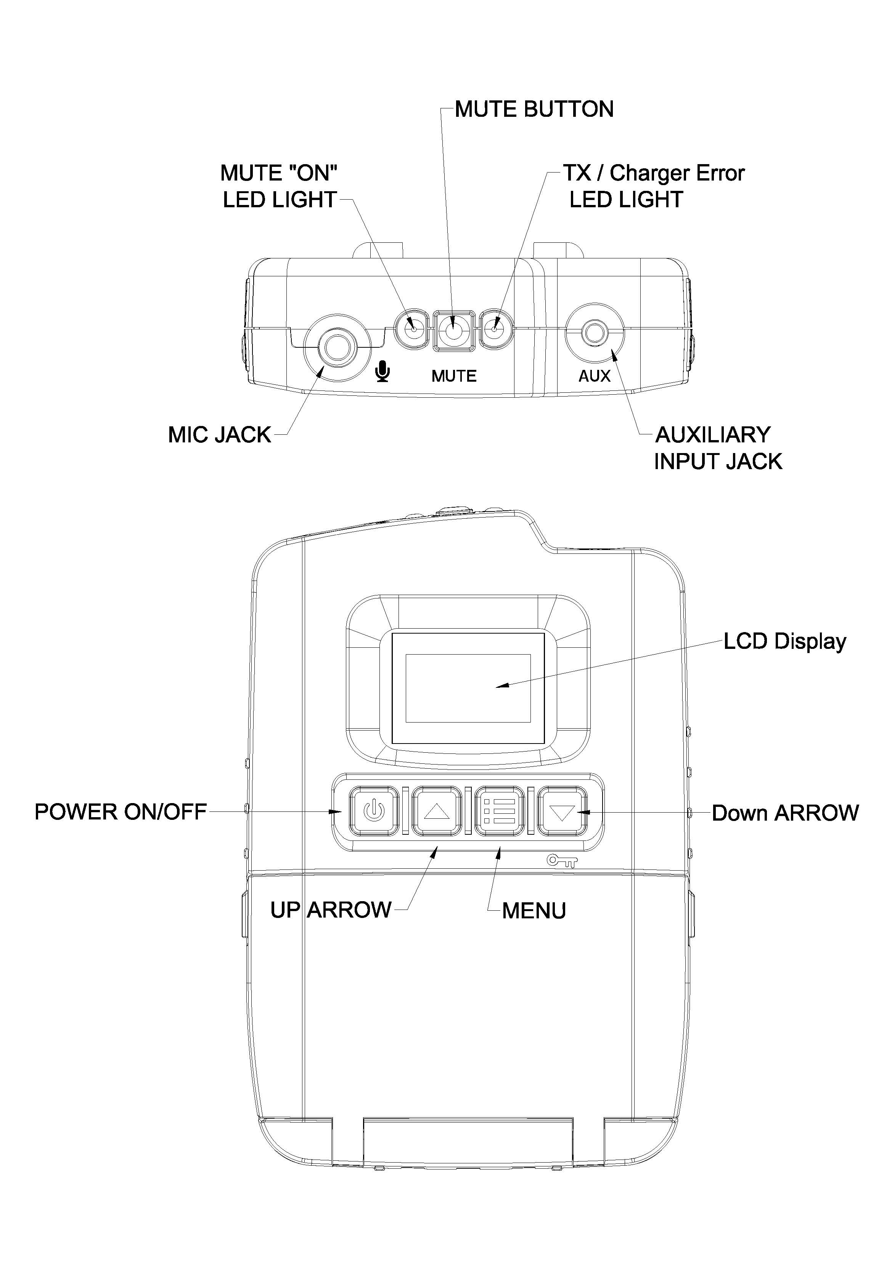**Quick reference: Controls, Displays and Connectors Top of Transmitter**

**Front of Transmitter**

**Optional CHR-600 Drop-in Charger Sold Separately.**

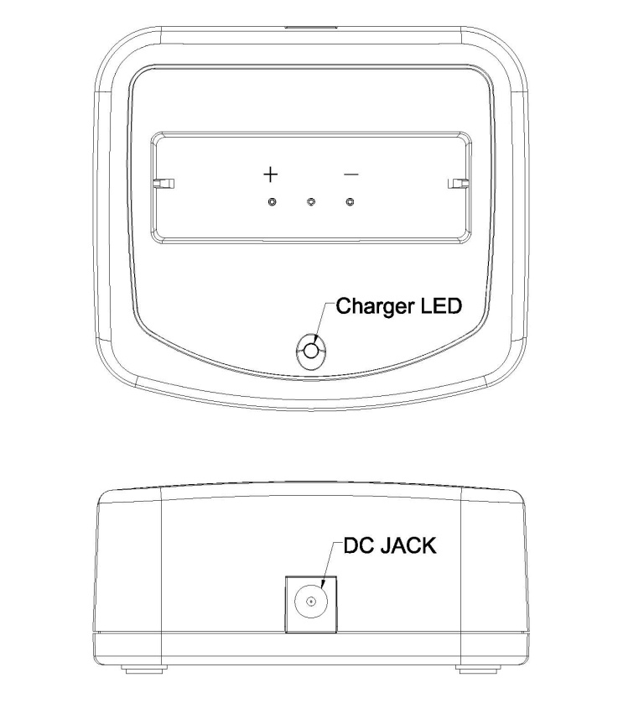

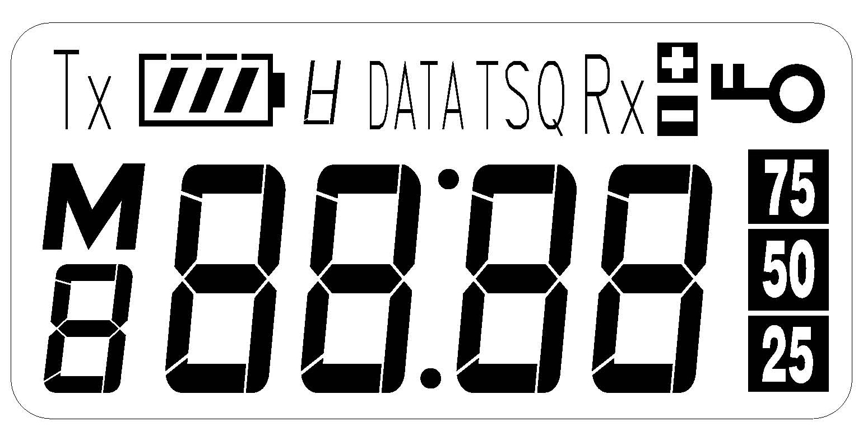**LCD Display**

1.  Battery Level Indicator
2.  2:1, 1:1 Compression Ratio
3.  Locked Buttons
4.  Mute Microphone Indicator (when

flashing) / Microphone Gain Setting Indicator

1.  Battery Type Setting Indicator

A= Alkaline r=Rechargeable

Function Indicator during “Menu” Operation

Preset 1 or 2 indicator during Bidirectional Mode

1. 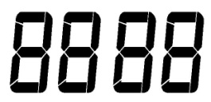 Main 4-Digit Display
2.  Audio Level / FM Deviation

**Set-up Instructions**

**General Set-up Instructions:**

* Unpack the transmitter: Remove outer packaging and plastic cover. Inspect for physical damage and immediately report any issues.
* Install batteries: Open the battery compartment by pressing and pulling the two locking tabs located at each upper side of the battery lid. Install 2 AA batteries. Use alkaline or NiMH batteries only *. Be sure to observe proper polarity (+/-). Damage due to improper battery installation may void the product warranty. The battery icon on the LCD display will flash when it is time to replace or recharge batteries.

*\*Note: Make sure the transmitter is set for the correct battery type. When powering on the transmitter, the LCD display will show for 2 seconds either “ALkA” or* *“rECH” indicating the transmitter setting. In addition, during Standard operation mode, on the left bottom corner of the LCD display you will see either an A (Alkaline) or r (rechargeable) also indicating the transmitter setting. If the setting does not match the type of battery you installed, go to Advanced Settings menu (See page 16) and select the correct battery type. Use* *“ALkA” for non-rechargeable alkaline batteries, “rECH” for rechargeable NiMH batteries only.*

*If the battery setting is not in the correct option, battery level indicator may be inaccurate, the unit may not charge, or alkaline batteries may explode if placing the unit in the charger. Caution! Never recharge alkaline batteries.*



* Turn the unit on: Press and hold the “POWER” button for 3 seconds. You can turn it off also by pressing and holding the “POWER” button for 3 seconds.

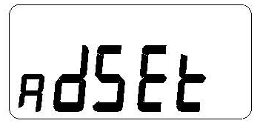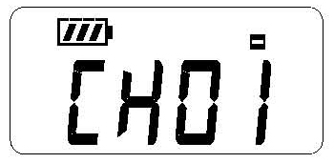

* Connect a microphone: Plug in an Enersound compatible microphone (sold separately) onto the “Mic Jack” on top of the transmitter and lightly screw in the locking nut clockwise.

*Warning: Do not tighten the nut excessively. Once you feel a little resistance, stop screwing.*

We recommend using the following Enersound compatible headset microphones: MIC-200SEN, MIC-400SEN, and MIC-500SEN. Other compatible microphones are MIC-300SEN and LAV-100SEN. Check for other Enersound compatible microphones at the time of purchase.

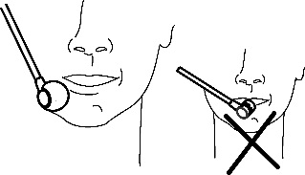When using a headset microphone, place the capsule at the corner of your mouth so that it rests at about 1 inch away from your face. Do not place it in front of your mouth!

* You may also plug in an auxiliary audio source, such as a CD or MP3 player using the “Aux Input” 2.5 mm stereo jack. If mic and auxiliary sources are used together, the audio will be combined. If only an auxiliary source is desired, the mic can be muted. *Important: Do not remove the mic from the “Mic Jack” as the microphone cable also functions as the transmitting antenna. When the antenna is correctly plugged in a green TX light will be lit.*
* Select channel: Choose the desired channel by

using the  UP or 4down arrow DOWN buttons on the front of the transmitter. If the unit is locked, unlock it by pressing and holding the DOWN button for 4 seconds.

Depending on the display mode, the screen will show either the channel number (channel mode) or the frequency (frequency mode).

If necessary, after selecting the desired channel, you can lock it by pressing and holding the DOWN button for 4 seconds.

Note: Make sure the FM receivers are tuned to the same frequency as the TP-600-4 transmitter. If you are using compatible Enersound receivers, the channels will correspond to the channels on the TP-600-4 transmitter. If you are using compatible receivers of other brands, frequencies may differ. Consequently, we recommend setting the Enersound TP-600-4 transmitter on Frequency Display mode.

To set the transmitter on Frequency Display mode, press and hold the MENU button for 5 seconds to access the Settings menu, then access Advanced Settings. See page 16 for more details.

**Enersound TP-600-4 Frequency Chart \***

|  |  |  |
| --- | --- | --- |
| **CH 1** | **72.1 MHz** |  |
| **CH 2** | **72.5 MHz** |  |
| **CH 3** | **72.9 MHz** |  |
| **CH 4** | **75.7 MHz** |  |

* Other frequencies are available upon request

* Locking/ Unlocking the transmitter:

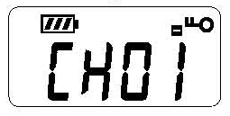

This function is used to lock all the buttons except the MUTE and POWER buttons. Press and hold 4down arrow the DOWN button for 4 seconds to lock the transmitter. The icon will appear on the screen. Press and hold the4down arrow DOWN button for 4 seconds again to unlock it.

* Muting/ Unmuting the microphone: To mute the microphone, press and release the MUTE button located at the top of the transmitter. The red MUTE light indicator will start flashing and an “M” icon will flash on the LCD display. To unmute the microphone, press and release the MUTE button again.

Note: The AUX Audio Input is not affected by the mic mute.

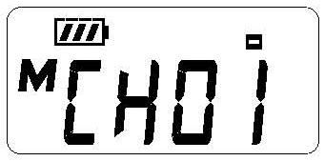

**Menu Setting Instructions:**

Press & hold the  MENU button for 4 seconds to access the Settings menu. To move to the next menu option, press and release the Menu button once. To modify option value, press the UP or DOWN buttons. If no button is pressed for 10 seconds, the transmitter will automatically exit the Settings menu. To exit the Settings menu, you may also navigate through all the options by pressing and releasing the Menu button repeatedly until exiting.

* Microphone Gain (Volume):

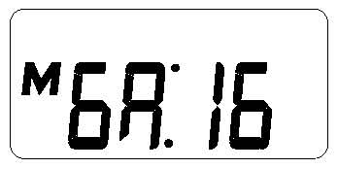

Press & hold the MENU button for 4 seconds. The LCD display will start blinking and the first option MICROPHONE GAIN will be shown.

Press the UP or DOWN button to increase or decrease the microphone gain (volume) between 0 and 32. The default gain is 16.

* 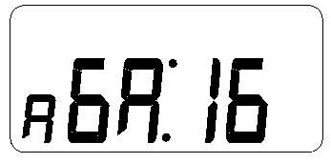Auxiliary Gain:

To move to the next setting, press and release the MENU button and AUXILIARY GAIN will start blinking. Press the UP or DOWN button to increase or

decrease the auxiliary gain (volume) between 0 and 32. The default gain is 16.

To move to the next setting, press and release the MENU button and ADVANCED SETTINGS will start blinking. To exit without entering Advanced Settings, press and release the Menu button again.

* Advanced Settings:



To enter Advanced Settings menu, while Advanced Settings is blinking, press the UP or DOWN buttons to select YES. Then, press the menu button once.

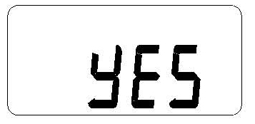The first Advanced Settings option, Compression Ratio, will start blinking.

* Compression Ratio:

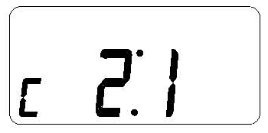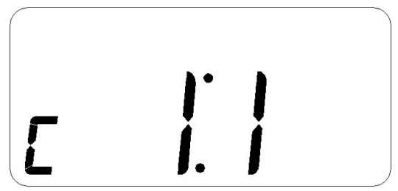

Audio Compression reduces the volume difference between loud and soft sounds. Press the UP or DOWN buttons to modify the compression.

1:1 = compression off

2:1 = compression on

* 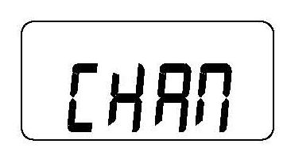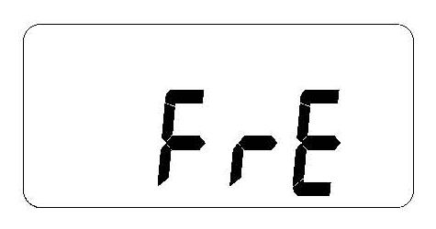Channel/ Frequency Mode:

You can choose the screen to show either channel numbers or frequencies. If you are using Enersound R-120 , R-100 receivers or other compatible Enersound receivers, the receiver channels will correspond to the TP-600-4 transmitter channels. If you are using compatible receivers of other brands, frequencies may differ. Consequently, when using receivers from other manufacturers, we recommend setting the Enersound TP-600-4 transmitter to Frequency Display mode.

While in the Advanced Settings menu, press the MENU button to navigate through the options until you reach CHAN/ FRE. When CHAN or FRE is blinking, press the UP or DOWN buttons to change the settings to Channel Display Mode (CHAN) or Frequency Display Mode (FRE). To exit the Menu, wait for 10 seconds or press the MENU button several times to navigate through the options.

* Battery Type:

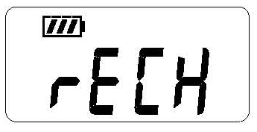

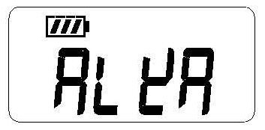

It is very important to select the correct battery type installed in your transmitter. Please see important note on Page 8 under Install Batteries in General Set Up Instructions.

While in the Advanced Settings menu, press the MENU button to navigate through the options until *ALkA or rECH is blinking*.

Press the UP or DOWN buttons to select the desired option *Use “ALkA” for non-rechargeable alkaline batteries, “rECH” for rechargeable NiMH batteries only.*

Note. When the transmitter is set to “ALkA” and the transmitter is placed on the charger, the LCD display with indicate “Error” and a green LED light will start flashing.

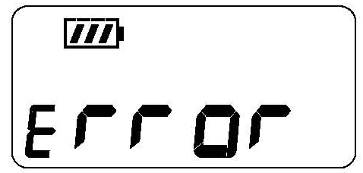

*Caution! Never recharge alkaline batteries.*

* *Clear data to factory default:*

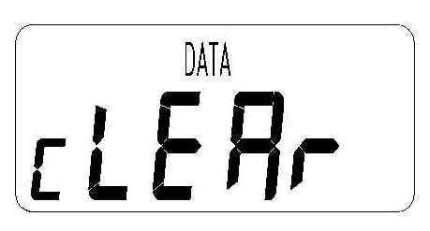

To restore factory default settings, while in the Advanced Settings menu, press the MENU button to navigate through the options until you reach “cLEAr”. Press the UP or DOWN buttons to select [Yes]. Then, press the menu button once to confirm.

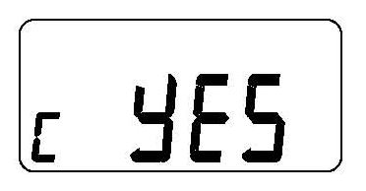

**Bidirectional, Two-Channel Mode:**

The Bidirectional Mode allows the user to easily switch between two preset channels or frequencies without passing through all the channels. Each preset has its own frequency/ channel. All other settings remain the same. To toggle between the two presets, press the UP or DOWN buttons. The DOWN button will set the transmitter to the channel or frequency defined in preset 1.

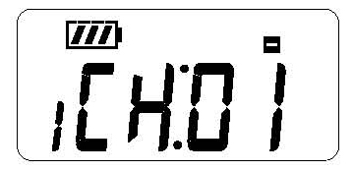

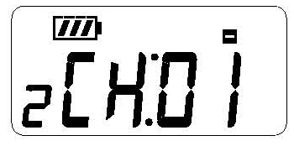The UP button will set the transmitter to the channel or frequency defined in preset 2.

Note: Only one frequency/channel can be transmitted at a time.

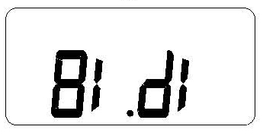**Setting the transmitter to bidirectional mode**

To set the transmitter to the bidirectional mode, with the transmitter powered off, press and hold the Power and Menu buttons together for 8 seconds until “Stan” appears. Press the UP button once to select “Bidi” and press Menu button.

To confirm your selection, press UP button until “Yes” appears. Then confirm by pressing the Menu button once. Wait a few seconds and the transmitter will be set to Bidirectional Mode.

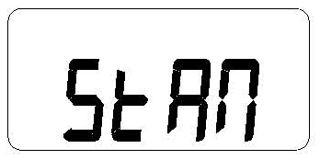

To go back to Standard mode, with the transmitter powered off, press and hold the Power and Menu buttons together for 8 seconds until “Bidi” appears Press the UP button once to select “StAn” and press the Menu button. To confirm your selection, press UP button until “Yes” appears. Then confirm by pressing the Menu button once. Wait a few seconds and the transmitter will be set to Standard Mode.

**Assigning a channel to each preset**

Once in the Bidirectional Mode, you must assign a channel to each of the two presets.

* To assign a channel or frequency to preset 1, first select preset 1 by pressing the DOWN button. Then, press and hold the Menu button for 4 seconds. Preset 1 Channel will start blinking.



Select the desired channel or frequency with the UP or DOWN buttons. Then, press the Menu button several times to navigate through all Menu options until exiting. All the options such Microphone Gain and Auxiliary Gain will be the same as in Standard Mode and will be shared by both presets. To modify any of these options, follow the steps explained in Menu Settings Instructions.

* To assign a channel or frequency to preset 2, first select preset 2 by pressing the UP button. Then, press and hold the Menu button for 4 seconds. Preset 2 Channel will start blinking.



Select the desired channel or frequency with the UP or DOWN buttons. Then, press the Menu button several times to navigate through all Menu options until exiting.



**Safety Information:**

**HAZARD! Pacemaker Safety**

* Before using this transmitter and/ or receivers with a pacemaker or another medical device, consult your physician or the manufacturer of your pacemaker or another medical device.
* If you have a pacemaker or another medical device, make sure that you are using this transmitter and/or receivers in accordance with safety guidelines established by your physician or the pacemaker manufacturer.

**WARNING! Damage to your Health**

* Using earphones or headphones at a loud volume or over a prolonged period of time can lead to permanent hearing damage. To protect your hearing and others:

1. Turn down the volume before putting on the earphones or headphones.
2. Adjust the volume at the minimum comfortable level.
3. If feedback (a squealing or howling noise) occurs, turn down the headphone volume, and move the microphone away from the receiver’s headphones.

**Other Safety Considerations**

* Do not leave the device in places with high temperatures or high humidity.
* Do not handle the charger power cord with wet hands.
* Keep this device away from fire and heat sources.
* Keep this product, accessories and its packaging out of the reach of children. Plastic bags, packing material, electrical cords and other accessories may cause choking, suffocation and/or electrocution!
* Do not open the unit. There are no user serviceable parts inside.
* Reduce the volume to its lowest setting before use.
* To clean the transmitter and the optional charger, be sure to first switch off and unplug the unit from the power outlet, then wipe with a dry cloth. When extremely dirty, use a soft cloth dampened in neutral detergent. Never use benzene, thinner or chemically-treated towels, which may damage the product’s finish.

**Recycling Instructions**

Help Enersound protect the environment by disposing of your TP-600-4 transmitter and accessories properly!

* Image result for battery recycling logo Please do NOT dispose of your Enersound equipment in the household trash. Take the equipment to an electronics recycling center.

Image result for battery recycling logo

* Please do NOT dispose of used batteries in the household trash. Please take them to your local collection point or recycling center. This will help to protect the environment.

**Troubleshooting**

**The transmitter will not power.**

* Verify that batteries are corrected installed and charged. Also, check for signs of battery leakage or corrosion.
* Make sure you are pressing and holding the POWER button for 5 seconds.

**There is no audio or the audio is low on the receivers.**

* Verify that both the transmitter and receiver are powered ON.
* Make sure that both the transmitter and receiver are on the same channel/frequency. If using receivers of other brands, check the frequency chart corresponding to the receivers’ channels. The frequency on both receivers and transmitter must match; channel numbers may not necessary be the same.
* Make sure that the mute function is off and that you are using a compatible microphone in working condition.
* Check the earphone/headphone connector is plugged in all the way on the receiver jack.
* Check the microphone and auxiliary gain levels. If necessary, adjust the gain.
* Make sure the microphone is plugged in as the cord serves as the transmitting antenna. The same applies to the receiver earphone/headphone cord, which also acts as the receiving antenna.
* When using the Aux input, verify the aux source is playing, and a microphone is connected on the transmitter mic input to serve as the antenna. You can mute the microphone if needed.

**There is too much ambient noise.**

* Adjust the microphone gain in the Menu.
* Place the microphone closer to the mouth.

**There is insufficient range**

* Make sure the microphone is plugged in as the cord acts as the transmitting antenna. The same applies to the receiver earphone/headphone cord, which also acts as the receiving antenna. Verify the cord is not coiled up.
* Verify that your receivers are working properly.
* Avoid obstacles between the listening area and the transmitter that may affect the signal strength, like partitions, metal objects, dense materials, studs, pipes, heating or AC ducts, metal grids or concrete.
* Try using a different channel/ frequency since a strong interfering signal may exist.
* Verify that the distance between the transmitter and receiver is within the specified range (150ft).
* Make sure no other transmitters are in the same area tuned in the same channel or interfering with the frequency.

**There is feedback (squealing noise).**

* Move away the receiving earphones from the transmitter microphone.
* Lower the microphone gain (volume) in the Settings menu.

**There is distortion in the audio.**

* Verify if the audio input level is too high that overloads the input. Adjust the gain if necessary.

**FCC Statement**

In the US, the FCC limits the use of this device to assistive listening and simultaneous interpretation. This transmitter cannot be used in all countries. Check with your government’s radio regulations for 72-76 MHz operation.

Any changes or modifications not expressly approved by the party responsible for compliance could void the user's authority to operate the equipment.

This device complies with part 15 of the FCC Rules. Operation is subject to the following two conditions:

(1) this device may not cause harmful interference, and

(2) this device must accept any interference received, including interference that may cause undesired operation.

**IC Statement**

This device complies with Industry Canada license-exempt RSS standard(s). Operation is subject to the following two conditions:

(1) this device may not cause interference, and

(2) this device must accept any interference, including interference that may cause undesired operation of the device.

This radio transmitter (TP-600) has been approved by Industry Canada to operate with the antenna types listed below with the maximum permissible gain and required antenna impedance for each antenna type indicated. Antenna types not included in this list, having a gain greater than the maximum gain indicated for that type, are strictly prohibited for use with this device.

The device is in compliance with RF field strength limits; users can obtain Canadian information on RF exposure and compliance.

Le présent appareil est conforme aux CNR d'Industrie Canada applicables aux appareils radio exempts de licence. L'exploitation est autorisée aux deux conditions suivantes:

(1) l'appareil ne doit pas produire de brouillage, et

(2) l'utilisateur de l'appareil doit accepter tout brouillage radioélectrique subi, même si le brouillage est susceptible d'en compromettre le fonctionnement

Le présent émetteur radio (TP-600) a été approuvé par Industrie Canada pour fonctionner avec les types d'antenne énumérés ci-dessous et ayant un gain admisible maximal et l'impédance requise pour chaque type d'antenne. Les types d'antenne non inclus dans cette liste, ou dont le gain est supérieur au gain maximal indiqué, sont strictement interdits pour l'exploitation de l'émetteur.

Le présent appareil est conforme Après examen de ce matériel aux conformité aux limites DAS et/ou aux limites d’intensité de champ RF, les utilisateurs peuvent sur l’exposition aux radiofréquences et la conformité and compliance d’acquérir les informations correspondantes.

**Limited Warranty Statement**

Enersound warrants the TP-600-4 motherboard to be free from defects in workmanship and material under normal use and conditions for 3 years from date of purchase from an authorized dealer. All other TP-600-4 parts or accessories, including shell, jacks, microphones, earphones, headphones, batteries, chargers, cables, carry cases, and other accessory products carry a one-year warranty from the date of purchase. This warranty is only available to the original end purchaser of the product and cannot be transferred. Damage due to battery leakage, and/or a result of charging non-rechargeable batteries, will VOID the product warranty. Damage due to, water, sweat, corrosion, humidity, extreme temperature, chemicals or any other external factor is not covered under this warranty. Reimbursement for your costs of removing and transporting the product for warranty service evaluation or installation of any replacement product are not covered by this warranty. If the product is determined to be defective, Enersound will repair or replace it, at its discretion, at no charge. Customer must pay for shipping, handling, insurance and any duties and taxes if applicable. This warranty is void if damage occurred because of misuse or if the product has been repaired or modified by anyone other than a factory-authorized service technician. Warranty does not cover normal wear and tear on the product or any other physical damage unless the damage was the result of a manufacturing defect.

Enersound has no control over the conditions under which this product is used. Therefore, the company disclaims all warranties not set forth above, both express and implied, with respect to the TP-600-4 transmitter, including but not limited to any implied warranty of merchantability or fitness for a particular purpose. Enersound products manufacturer, distributors and/or dealers shall not be liable to any person or entity for any medical expenses or any direct, incidental or consequential damages caused by any use, defect, failure or malfunction of the product, whether a claim for such damages is based upon warranty, contract, tort or otherwise. The sole remedy for any defect, failure or malfunction of the product is replacement of the product. No person has any authority to bind Enersound to any representation or warranty with respect to the Enersound TP-600-4 transmitter. This warranty gives you specific legal rights, and you may also have other rights, which vary from state to state. Some states do not allow limitations on how long an implied warranty lasts, and the exclusion or limitation of incidental or consequential damages, so the above limitation may not apply to you. This warranty does not cover products sold AS IS or WITH ALL FAULTS. For products sold outside the U.S., please consult with your local dealer about any terms and conditions applicable in your country. Proof of purchase in the form of a bill of sale, invoice number or receipted invoice, which is evidence that the unit is within the warranty period, must be presented to obtain warranty service. If you experience any issues with your transmitter, send an email to support@enersound.com with your name, address, phone number and a complete description of the problem. We will respond to you as soon as possible and if it is necessary to return the product for service, your Customer Service Representative will give you a Return Authorization Number (RAN) and shipping instructions. Our address is 5869 SW 21st Street, West Park, FL 33023, USA.

For more information, visit [www.enersound.com](http://www.enersound.com).

You may also call 1-305-731-2416 or our toll-free number 1-800-644-5090 within the US.

**TP-600 Optional Accessories**

|  |  |
| --- | --- |
| CHR-600 | Drop in charger for TP-600 with power supply |
| MIC-200SEN | Headband microphone with 3.5mm locking plug (black) |
| MIC-400SEN | Earset Microphone with 3.5mm locking plug (beige) |
| MIC-500SEN | Miniature Pro Headset Microphone with 3.5mm locking plug (beige) |

To purchase accessories, contact your local dealer.

If you are unable to find a dealer in your area, contact us for more information:

Toll free: 1-800-644-5090

International: +1-305-731-2416

info@enersound.com

[www.enersound.com](http://www.enersound.com)

|  |  |  |
| --- | --- | --- |
|  | **Specifications: TP-600-4 FM Transmitter** | |
| **RF** | Operating Frequency | 72.1, 72.5, 72.9, 75.7MHz * |
| Number of Channels | 4 Selectable |
| Frequency Deviation | Wide Band: +/- 75KHz |
| Transmitter Stability | +/- 10ppm |
| Output Power | Hi: 80,000uV/m at 3meter |
| Antenna | Integral with microphone cord |
| Compliance | FCC part15, Industry Canada |
| **AUDIO** | Frequency Response | 180Hz ~15KHz |
| Signal to Noise Ratio | 67db |
| System Distortion | < 1% (THD) at 45KHz deviation. |
| MIC Input | Locking 3.5mm 1/8’’ TRS jack, supplies +DC on tip for electret mics. |
| AUX Input | 2.5 mm stereo jack w/adjustable gain |
| Audio Processing | Built-in signal compression 2:1. |
| **POWER** | Battery Type | (2) AA 1.5 V non-rechargeable Alkaline |
| (2) AA 1.5 V NiMH rechargeable |
| Battery Life | Up to 25 hours with alkaline batteries |
| Up to 22 hours per charge, recharges in 6-7 hours with CHR-600 drop in charger |

* Other frequencies are available upon request

|  |  |  |
| --- | --- | --- |
|  | **Specifications: TP-600-4 Continuation** | |
| **ENVIROM.** | Temp. Operation | -5℃ (23F) to + 40℃ (104F) |
| Temp. Storage | -20℃ (-4F) to + 60℃ (140F) |
| Humidity | 0~95% Relative Humidity |
| **PHYSICAL** | Dimensions | Without Belt Clip: 4.1” x 2.8” x 0.9” (104mm x 71mm x 23mm) With Belt Clip: 4.1” x 2.8” x 1.1” (104mm x 71mm x 27mm) |
| Color | Black |
| Unit Weight | 2.9 oz (84 gr) without batteries |
| Shipping Weight | 2.2 lbs. (1.1 Kg) |
| **OTHER** | Warranty | 3-Year Limited Warranty on motherboard , 1 year on Accessories and other parts |
| Controls Buttons | Power, Up, Down, Lock, Menu & Mute |
| Indicators | LCD display with backlight Green LED transmitting indicator Red LED Mute indicator |

We reserve the right to make technical and design modifications to the transmitter without notice.

©2020 Enersound. All rights reserved.